Cost Monitoring and Control Policy
Effective January 1, 2024

Enacted

John McPhail
President & CEO

Table of Contents
1. Objective 3
2. Cost Control - Expenditure Reporting Process 3
2.1 Field Office and Subrecipient Financial Reports 3
2.2 Home Office Accounts Payable – Bill.com 4
2.3 Field Office Accounts Payable – PandaDoc & Replicon 5
2.3.1 Payment Requests in PandaDoc 5
2.3.2 Payment Requests in Replicon 6
2.4 Credit Card Expenses - Bill Spend & Expense 6
2.5 HO Payroll Entries - Paycom 6
2.6 FO Payroll Entries 7
2.7 Other Journal Entries 7
3. Cost Monitoring Procedures 7
3.1 Federal Financial Reports (SF-425) 7
3.2 Compliance Report & Feedback for FO & Subrecipient Financial Reports 7
3.3 Compliance Spot Checks 8
3.4.1 Grant Report Analysis 8
3.4.2 Budget vs. Actual 8
4. Reclassification of Expenses Procedure 9
5. Budget (Cost) Adjustment Procedure 9
6. Program Technical Narrative (Performance) Report 10
7. Compliance Matrix 10

Objective
Cost monitoring and control are essential aspects of Partners of the Americas Inc. (Partners) financial management. These processes help ensure that grant funds are used efficiently, effectively, and in compliance with award requirements, 2 CFR 200 and the FAR (as applicable). Cost monitoring involves regularly tracking and analyzing expenses to assess whether they align with the approved award budget and program objectives. Cost control also involves identifying errors, taking corrective actions, and implementing strategies to manage costs within the approved budget. The following are key components of Partners cost monitoring and control.

Cost Control - Expenditure Reporting Process
An effective expense report process is a critical part of Partners’ cost monitoring and control procedure. The goal is to track and record expenditures, perform compliance checks, and audit, in order to deliver clear and accurate reports. The following are the main sources of expenditures and their cost control process for entering transactions into Sage Intact.

Field Office and Subrecipient Financial Reports
The below flow charts outline the process that field office (FO) and subrecipient financial reports follow for review, audit, and upload into Partners financial system Sage Intact.
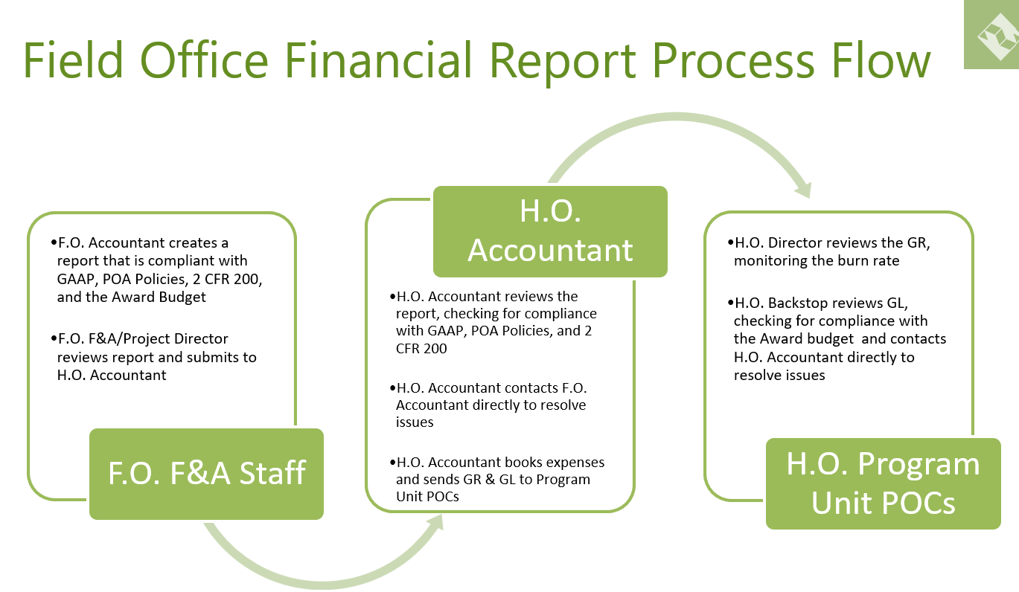
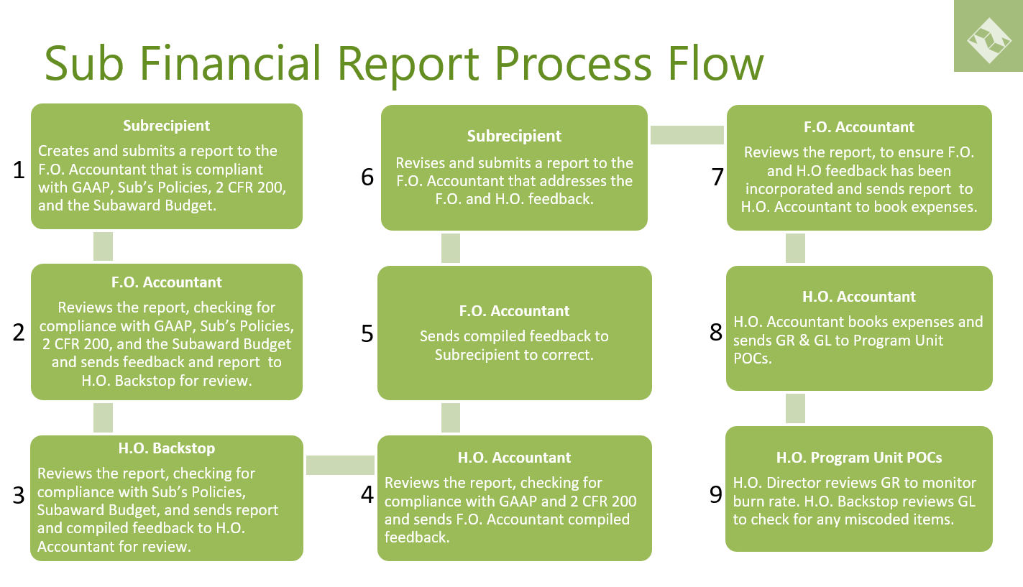

Home Office Accounts Payable – Bill.com
In order for home office (HO) finance department to process payments to a vendor, technical approval is required from the Vice President/HO Director/HO Associate Director/Chief of Party(COP)/Project Director (PD), as appropriate based on Partners Delegation of Authority Policy. For HO the review, audit, and approval process will be done in Bill.com. HO staff should reference the training materials on bill.com. Once approved in Bill.com, the transactions are automatically synced with Sage Intact accounting software. The flow chart below highlights the roles and responsibilities of each individual in the Bill.com approval process.

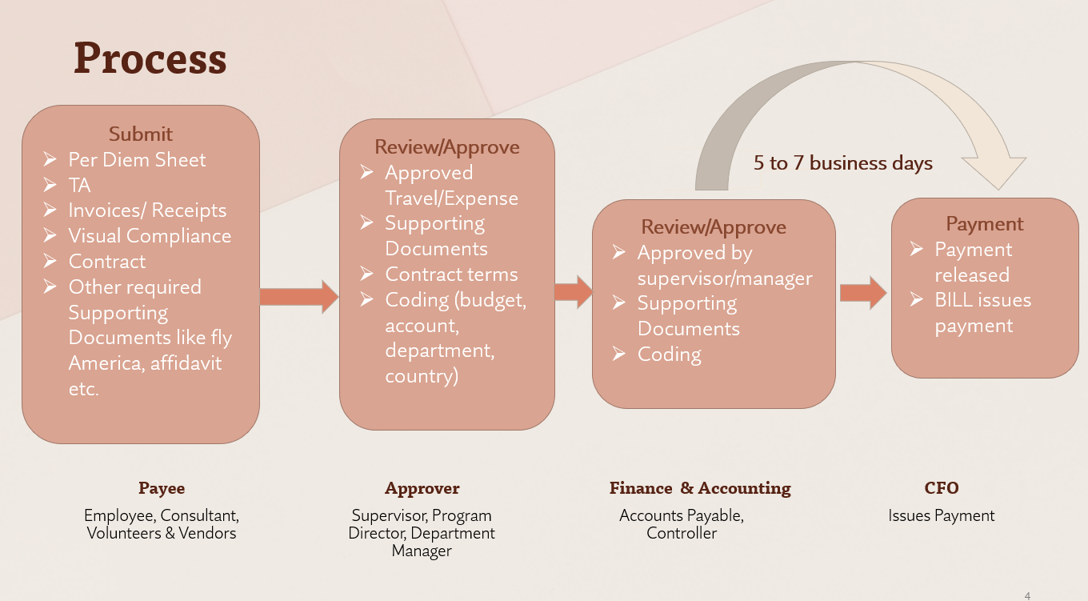

Field Office Accounts Payable – PandaDoc & Replicon
For the FO, the review, audit, and approval process will be completed via a payment request form in PandaDoc or in Replicon based on the guidance below. It is important that an invoice or receipt is created by the vendor, not Partners. It must include vendor, date, amount, item, and quantity. All invoices shall be stamped “Paid” and written date of payment or attached the transfer payment. Once payment in either system are approved, they will be reported as part of the FO financial report for upload into Sage Intact (see section 2.1 FO and Subrecipient Financial Reporting).

Payment Requests in PandaDoc
Payment request forms apply to all purchases made from any Partners bank account, Airtm account, PayPal account, Western Union, or any other payment processing platform. The payment request form does not apply to purchases made with petty cash, any corporate credit cards, or staff travel/other expense reimbursements (see 2.3.2 Payment Requests in Replicon below).
In PandaDoc, the payment requestor should initiate the payment request form. FO staff will need to complete the payment request form, attach an invoice, copy of the contract, Visual compliance check, and all other necessary supporting documentation. Please reference the supporting documentation checklist for this list of necessary documentation for each payment type. These required documents should be uploaded into PandaDoc.
The form should be routed first for technical approval from the Vice President/HO Director/HO Associate Director/COP/PD, as appropriate based on Partners Delegation of Authority Policy. Once approved, the form will be routed to the FO Finance Department for audit, approval, and processing.
The F&A Director will only make payments on expense vouchers that have been fully approved and include all the necessary supporting documentation. The F&A Director must verify and match up the vendor invoice, supporting documentation, the procurement file, and the signed payment request. While Partners is normally exempt from taxes, if Partners must withhold taxes in a certain situations, the finance department will be responsible for withholding taxes and remitting the payment to the appropriate tax authorities. All payments must be made in accordance with the contractual terms between the Partners and vendor, and Partners’ policies.
Once fully approved, PandaDoc will create a single file PDF of the payment request and all the supporting documentation.

Payment Requests in Replicon
For travel and/or other expense reimbursements, all field staff will use Replicon to submit reimbursement request, therefore, they do not require a payment request form in PandaDoc. In the Replicon platform, field staff will submit their expenses for reimbursement, then the payment will go to their supervisor for review, audit, and approval. Once the supervisor approval is obtained, the FO Finance Department will audit, approve, and process the reimbursement. The F&A Director will only make payments on expense vouchers that have been fully approved and include all the necessary supporting documentation.

Credit Card Expenses - Bill Spend & Expense
Partners uses Bill.com (Divvy) Spend & Expense platform for processing of all credit card transactions. All credit card holders will need to login weekly on the app or website to upload supporting documentation, receipts, and proper coding for all expenses. By the 5th of each month supervisors must enter into the platform and audit, review, and approve the expenses. If the 5th falls on a holiday or weekend, supervisors must approve the business day prior. Once approved in Bill.com (Divvy) Spend & Expense, the transactions are automatically synchronized with Sage Intact accounting software.

HO Payroll Entries - Paycom
Partners uses Paycom for all HO payroll transactions. Prior to each pay period the HO Budget Analyst in coordination with the HR Officer creates the payroll ledger. The payroll ledger is then sent to the Controller or CFO for review and approval. Once approved, the payroll is processed by Paycom. After the Controller or CFO will download a copy of the final processed payroll ledger and send to the HO Budget Analyst to prepare the upload into Sage Intact. Once in Sage Intact, the HO Controller reviews, audits, and approves the transactions for posting into the system.

FO Payroll Entries
Before payment, the payroll processer in each country sends the payroll ledger to the COP/PD and the HO Associate Director/HO Director for review and written approval via email. Before processing payroll, the COP/PD and the HO Associate Director/HO Director is responsible for ensuring all timesheets are submitted and approved for the period. Once the payroll processer completes payroll, it is reported as part of the FO financial report for upload into Sage Intact (see section 2.1 FO and Subrecipient Financial Reporting).

Other Journal Entries
These are transactions outside the above-mentioned expenses. It includes but not limited to recording of drawdowns, bank fees, depreciation, revenue recognition, and indirect cost allocation. These entries are prepared by the HO Accountants and entered into Sage Intact. Once in Sage Intact, the HO Controller reviews, audits, and approves the transactions for posting into the system.

Cost Monitoring Procedures
HO Finance Departments reviews and records all Partners’ financial transactions in Sage Intact and issues monthly grant reports and financial reports on organizational level. Program teams have full access to Sage Intact to review their respective grant reports at any time. Below are the different types of reports to monitor costs once entered into Sage Intact.

Federal Financial Reports (SF-425)
HO Finance Department prepares and submits financial reports on Payment Management System (PMS) and other platforms according to each award agreement reporting frequency. The total expenditures reported on the donor financial reports, always match the total expenditures for the period in Sage Intact. Therefore, it is critical that program teams login and review their financial reports monthly in Sage Intact.

Compliance Report & Feedback for FO & Subrecipient Financial Reports
Monthly, the HO Finance Department documents compliance findings from FO and subrecipient financial reports review. Each quarter the HO Finance Department emails a compliance report to FO F&A Director, FO Accountant, Program Director/Associate Director, Program Officer, and Compliance Director.

Program teams are required to review the compliance report and provide a response and follow up action plan to resolve any outstanding items. The HO Finance Department and the Compliance Director will review the reports and determine what additional trainings may be needed, and provide the team with the appropriate training and resources.

Compliance Spot Checks
The Compliance Director periodically performs spot checks on transactions and financial reports to ensure they are compliant with GAAP, Partners or Subrecipient Policies, 2 CFR 200, the FAR (as applicable), award budget, award budget narrative, and award provisions. Spot check reports are provided to FO F&A Director, FO Accountant, Program Director/Associate Director, Program Officer, Vice President of Programs, and the HO Finance Department. Based on the results of the random spot checks, the Compliance Director will provide additional trainings and resources to the Program and/or Finance team as necessary.

  - Monitoring Grant Expenditures
The HO Program Director/Program Office are responsible for reviewing the following reports in Sage Intact. This entails receiving and thoroughly evaluating the monthly grant report from F&A, acknowledging the receipt of the grant report, and confirming the completion of their review process. Below are key aspects of the grant report review process:
- Evaluate budget vs. Actual for each budget line.
- Verify budget categories are under the 10% budget flexibility test.
- Calculate the burn rate and adjust forecast as needed, both for life of program and Partners’ FY projection.
- Submit reclassification request for errors and or expenses without budget.

Grant Report Analysis
Monthly, the HO Program Director/Program Office are responsible for:
- Reviewing and monitoring monthly grant-related expenditures;
- Ensuring that costs are charged to the appropriate grant budget and account codes;
- Determining if reclassification of costs is needed; and
- Verifying the accuracy and completeness of financial transactions related to the project.

Budget vs. Actual
Regularly, the HO Program Director/Program Office are responsible for comparing the actual expenses to the approved project budget and highlighting the following:
- Identifying any significant variances and investigate the reasons behind them;
- Analyzing the impact of deviations from the budget on the project's overall financial performance; and
- Determine if budget modifications are needed.
    - Cash Flow Management
Cash management is a critical part of monitoring and planning for costs. On a monthly basis Program Directors must:
- Monitor the flow of grant funds to ensure that expenditures are adequately funded.
- Implement cash flow projections to anticipate any shortfalls or surpluses in funding.
Refer to Partners’ Request for Funding Policy for additional information.

Reclassification of Expenses Procedure
Reclassification requests are created by the Program Team and submitted using the form in PandaDoc. The submitter will be the individual creating the reclassification request. The approver will be the Vice President/HO Director/HO Associate Director/COP/PD, as appropriate based on Partners Delegation of Authority Policy.
All reclassification requests must be completed in PandaDoc and contain the following information:
- Complete description of expenses to be reclassified (budget (activity) code, funder/grant, account code, amount, and transaction reference number)
- If reclassification is related to payroll, the request must specify related timesheet.
- Complete description of new/updated (budget (activity) code, funder/grant, account code, amount, and transaction reference number).
- Justification for the reclassification.
- Funding shortage/overage cannot be part of justification.
- Signature of appropriate program manager of all programs affected by the reclassification based on the Partners Delegation of Authority Policy.

Budget (Cost) Adjustment Procedure
When necessary, adjustments to project budgets based on changes in scope, unforeseen circumstances, or external factors may lead to budget modifications. Program director must obtain necessary approvals for budget modifications from the donor before making any changes in the financial reporting system. Sage Intact budgets will only be updated once an approved budget modification from donor is received and submitted to Awards-Mods@partners.net.

Program Technical Narrative (Performance) Report
A program technical narrative or performance report is a document that provides a comprehensive overview of the effectiveness and outcomes of a particular program. This report includes detailed information on the program's objectives, activities, achievements, challenges, and impact. It serves as a valuable tool for program managers and funders to assess the success and efficiency of the program. The content and structure of a program performance report is based on the nature of the program and the reporting requirements of the award. Program teams are responsible for submitting the programmatic technical narratives/performance reports as required by their donor and the award.

Compliance Matrix
Effective October 1, 2023, all current and new award at Partners are required to have a Compliance Matrix. This document is intended to serve as an overview of the key award compliance aspects and provide a way of tracking and organizing progress. The matrix will provide a snapshot overview of the award, MEL plan, environmental plan (as applicable), highlight special provisions/restrictions, key decision made by the AOR/GOR, and flag and major compliance issues/concerns.

The “award summary page” tab will be completed for the prime agreement, and the “subaward summary page” tab for any subawards (duplicate tab for multiple subrecipients). The “compliance matrix details” tab provides an example breakdown, but will need to be customized based on each award. This compliance matrix details tab will confirm submission dates and track compliance with award terms and conditions, MEL plan indicators, budget narrative, work plan, etc.

Home office backstops will be responsible creation and the regular updates to the compliance matrix. The matrix will be approved twice annually by the Compliance Team, the respective Senior Program Director, and the Senior Vice President of Programs at the end of April and October each calendar year. Confirmation of the review and approval should be documented in writing via email.

